Society for Utopian Studies Annual Meeting
Toronto, Canada 2012
A Practical City Guide for Neighborhoods, Restaurants & Entertainment
PART (1) Getting Around Toronto (Transit – TTC)
http://www.ttc.ca/Subway/interactivemap.jsp
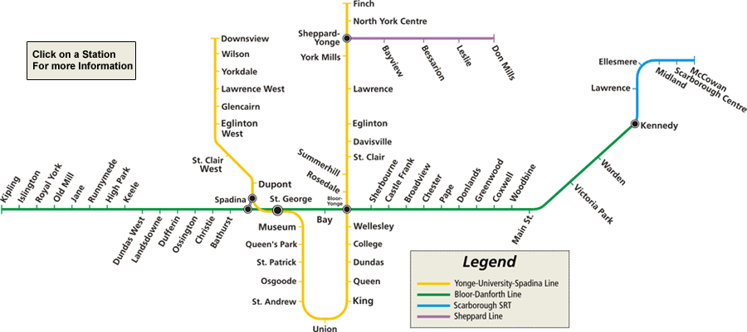
Yonge-University-Spadina Line: The 1 Yonge-University-Spadina Subway has 32 stations, and is a “U-shaped” subway route running generally in a south and then north direction. The route operates from the northern area of Yonge Street and Finch Avenue East, south to Union Station in downtown Toronto, and then north again to the area of Allen Road and Sheppard Avenue West. The Yonge-University-Spadina Subway connects with the Bloor-Danforth Subway at Bloor-Yonge, St. George and Spadina Stations, and it connects with the Sheppard Subway at Sheppard-Yonge Station.
Bloor-Danforth Line:
The 2 Bloor-Danforth Subway has 31 stations, and is a subway route running generally in an east-west direction along Bloor Street West, Bloor Street East and Danforth Avenue. The route operates from the western area of Dundas Street West and Kipling Avenue, east to the area of Bloor Street and Yonge Street in downtown Toronto, and continues east to the area of Eglinton Avenue East and Kennedy Road. The Bloor-Danforth Subway connects with the Yonge-University-Spadina Subway at Bloor-Yonge, St. George and Spadina Stations, and it connects with the Scarborough RT at Kennedy Station.
PART (2) Toronto Neighborhoods at a Glance
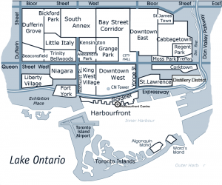
http://www.frommers.com/destinations/toronto/0034021098.html - link to a general overview of Toronto’s “must see” neighborhoods – this is a good start; it’s also a wide spread!

Also try: http://www.torontoneighbourhoods.net/

Here are two intersections that will lead you to a variety of great restaurants, shops, and local attractions:
A) College and Spadina, by TTC:
…this intersection will take you to:
- Little Italy (College Westbound), http://www.littleitalycollegest.com/
- to Chinatown (Spadina southbound), http://www.toronto-chinatown.info/
- to Queen St West (Spadina Southbound), http://www.showmetoronto.com/toronto_tour_queen_st_west.htm
- and to Kensington Market (Spadina Southbound to St. Andrew), http://www.kensington-market.ca

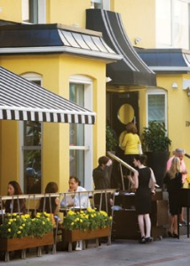
B) Front and Church, by TTC:
…this intersection will take you to:
- Old Town Toronto (Front St, at the Gooderham Building, East of Yonge),
- St. Lawrence Market (Front Eastbound), http://www.stlawrencemarket.com/
- Cabbagetown: Church-Wellesley Village (Church Northbound), http://www.churchwellesleyvillage.ca/
- The Esplanade (Church Southbound, one block from Front St. E.)
- Historic Distillery District (Southbound on Parliament at Mill St.) http://www.thedistillerydistrict.com/
- Harbourfront / Toronto Harbour http://www.torontoharbour.com/
- The Beaches - http://www.thetorontobeaches.com/
How to get there: TTC - Take the Yonge Line southbound down to Union Station. Walk east on Front St.

C) Yorkville / Shopping on Bloor Street (Holt Renfrew / Manulife Centre)
Yorkville Area Options (Walk North on Bay / Yonge to Bloor Street)
http://www.bloor-yorkville.com/Directory/Dining-Night-Life.aspx
SEE SUS BLOG for suggestions: http://greatfoodtoronto.wordpress.com/yorkville-area/

D) Honorable mentions: (More popular intersections)
- Dundas Square, at Yonge and Dundas http://www.ydsquare.ca/web/
- Ossington Village http://ossingtonvillage.com/
- Ronsesvales Village http://www.roncesvallesvillage.ca/index.php?l=neighbourhood
- Cabbagetown http://cabbagetowntoronto.com/
- King West Village (Spadina Southbound, West of Spadina on King)
- Mirvish Village: http://mirvishvillagebia.com/
- The Annex: http://www.theannex.com (Bloor Street from Spadina to Bathurst)
- Summerhill / Rosedale: http://www.torontolife.com/daily/daily-dish/neighbourhoods/2011/04/08/rosedale-summerhill-guide-22-need-to-know-places-along-yonge-streets-poshest-stretch/
These intersections are neighborhood hubs: there are many, many attractions, both great and modest, totaling hours of exploration time.

PART (3) PLACES TO EAT: ($, $$, $$$, $$$$, $$$$$)
Below are a few suggestions for dining, for exploring, for imbibing, and for late-night snacking, in these and other areas around the city, all of which are accessible by TTC or the old “Heel-Toe express:”
a) BRENDON’S HIDDEN GEMS
*Grand Electric – it’s a trek, but awesome!! Bourbon bar and latin cuisine, a must! (Parkdale) SSS
*Bar Volo – if you love beer, go here! Ask for the 587 platter with Duck prosciutto. (587 Yonge) $$$
Biff’s Bistro - $1 Oysters every day! Great patio too and free parking. (Front & Yonge) $$$
Oyster Boy – the Maritimes, only in Toronto! My favorite seafood place. (Trinity Bellwoods) $$$
Barque Smokehouse – smoked everything. Get the sampler platter. (Roncesvales Village) $$$
Hopgood’s Foodliner – trendy seasonal. Have the surf and turf tartar! (Roncesvales Village) $$$
The Black Hoof – game meat and wild food. Bone marrow, duck carpaccio. (Ossington Vil.) $$$
*WURST – a modern German brathaus. Duck sausage, Kangaroo Sausage. (King West) $$

b) BREAKFAST
Le Petit Dejeuner – great for brunch; eggs benedict is a must! (King and Yonge) $$
Over Easy – Hidden gem; breakfast benedict poutine. (King and Yonge)
Sunset Grill - Opens at 7 a.m. (Bloor and Church)
Bonjour Brioche - French (Cash only) $$
Flo's Diner - Yorkville $$
Aunties and Uncles - http://auntiesanduncles.ca/
===========================
OTHER LINKS: Best all-day breakfast in Toronto
http://www.blogto.com/toronto/the_best_all_day_breakfast_in_toronto/
b) BARS / WINE BARS
Bier Market: http://www.thebiermarkt.com/
Bar Volo
Spice Route – King West Village $$$
C’est What? – Front and Church $$
The Wine Bar – Front and Church $$$
Sassafraz – a favorite of Keith Richards, etc. Yorkville $$$$
Amsterdam Brewery – Thursday night rooftop patio bar. (Lakeshore) $$
Visit: The Historic Distillery District in Toronto - http://www.thedistillerydistrict.com/
c) NEW TORONTO DINING
Elm Street Restaurants: there are several to choose from, each of which is great; and one street south of the Delta Chelsea. Also, try…
Salt Wine Bar – tapas and charcuteria. (Ossington Village) $$$ - http://saltrestaurant.ca/
Parts and Labor – have the rabbit, or the Markrel and Shrimp. (Parkdale) $$$
Bier Markt – Oktoberfest! Plus the most extensive selection of beer in the city. (King West) $$$ - http://www.partsandlabour.ca/
Fat Cat Bar and Bistro – eclectic, vegetarian friendly; escargot, poached pear salad. (Roncesvales) $$$
Three Brewers – great beer, good food! (Yonge and Dundas) $$
The St. Lawrence Market – great on Sundays for exploring and for grabbing a quick bite. $$ - http://www.stlawrencemarket.com/
Gino Rana’s – ask to eat in the old bank vault; gnocchi, lamb shank. (Leslieville) $$$
Jumbo Empanadas – a gem in Kensington; great patio. (Kensington Market) $$ - http://www.jumboempanadas.com/
Burrito Banditos – best Mexican snack food in town.. hands down. (Entertainment Dist.) $
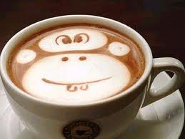
c) CB’s “UTOPIAN” COFFEE STOPS
Zaza Espresso Bar - http://zazaespressobar.com/ (Yorkville – Bay / Bloor) – Italian Coffee
Aroma Espresso Bar - http://www.aroma.ca/ (Bloor / Bathurst) – Lovely breakfast as well (Annex)
Green Beanery - http://www.greenbeanery.ca (Bloor / Bathurst) – Organic Coffee
Jetfuel - http://jetfuelcoffee.com/ - Parliament (A famous coffee spot in Toronto – Margaret Atwood and Michael Ondaatje are regular customers)
Snakes and Lattes - http://www.snakesandlattes.com/ (board games + coffee); a unique Toronto coffee experience ($5 extra to play)
Caffe di Portici – Great pizza + Lavazzo Coffee; lovely Red Velvet cake (In Yorkville) https://www.facebook.com/caffeportici
BEST COFFEE ROASTERS in TORONTO:
http://www.blogto.com/toronto/the_best_coffee_roasters_in_toronto/
Little Italy Cafes (Take your pick down the strip): http://www.blogto.com/cafes/n/22/littleitaly
The Annex: http://www.theannex.com/index.html (Spadina / Bloor to Bathurst / Bloor)
d) FINE DINING
Canoe – critically acclaimed; modern Canadian cuisine, including game. (Bay and Wellington) $$$$$ - http://www.oliverbonacini.com/canoe.aspx
Luma - $$$$$ http://www.oliverbonacini.com/Luma.aspx (In the Bell Tiff Lightbox Building on King Street)
Fisherman’s Wharf – one of Toronto’s best fine seafood restaurants. (Bay and Richmond) $$$$$
La Maquette – contemporary French cuisine. (King East and Church) $$$$$ http://www.lamaquette.com/
The Boiler House – contemporary Canadian. (Distillery District) $$$$$ http://www.boilerhouse.ca/
Tappo – Italian cuisine; classic cuisine. (Distillery District) $$$$$ - http://www.tappo.ca/
Rosewater - http://www.libertygroup.com/rosewater/rosewater.html
One - $$$$$$ http://www.onehazelton.com/
e) CHINESE (NORTH / SOUTH)
LEE – Celebrity chef Susur Lee’s more casual and affordable restaurant. (King West Village) $$$ - http://www.susur.com/lee/
Tao’s Tea Leaf – An authentic Chinese Tea Shop http://www.taotealeaf.com/ (Summerhill)
NORTHERN STYLE (Chinatown)
- Asian Legend (http://www.yelp.ca/biz/asian-legend-toronto) $$
- Dumpling House (http://www.yelp.ca/biz/dumpling-house-restaurant-toronto) $
- Chinese Traditional Bun (http://www.yelp.ca/biz/chinese-traditional-bun-toronto) $
- Sichuan Secret (585 Bloor Street West) - http://www.sichuansecret.com/
CANTONESE STYLE (Southern)
- Rol San (http://www.yelp.ca/biz/rol-san-restaurant-toronto) -– Sichuan Chinese; dim sum; great crispy spicy beef. (Chinatown, North of Dundas) $$
- Swatow (http://www.yelp.ca/biz/swatow-restaurant-toronto) $$
- King Noodle (http://www.yelp.ca/biz/kings-noodle-restaurant-toronto) $

f) Greektown (Danforth)
(go North on the Yonge Line; Switch to Bloor line heading East to Kennedy)
http://www.greektowntoronto.com/businesses.php?category=10
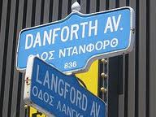
(416) 466-7771 – Megas $$ www.megasrestaurant.com
(416) 778-5150 - Mezes $$ www.mezes.com
(416) 461-3073 – Christina’s $$ www.christinas.ca
or Hop off at Chester Station and wander.
Dessert / Coffee
Athens Pastries: http://www.blogto.com/bakery/athenspastries

g) Japanese (Sushi / Ramen / Izakaya)
Japango (Elizabeth St.) http://www.blogto.com/restaurants/japango
Kenzo Ramen: $/$ - Best Ramen in the City http://www.kenzoramen.ca/
Sushi Inn (Yorkville) - http://www.sushiinn.net/
Guu Izakaya - http://guu-izakaya.com/toronto/ - Great Sake Selections + Izakaya Style Menu
Nami - http://www.namirestaurant.ca/

h) Indian Food / Little India
The Host: http://www.welcometohost.com/
Babur (http://www.yelp.ca/biz/babur-restaurant-toronto) OR: http://webandgraphic.ca/Babur.aspx?P=H
Maroli - http://www.maroli.ca/
OR
Visit – Toronto’s Little India (http://www.littleindia.ca/) and wander Gerrard St. for great buffets or the best Dosas in Toronto - http://www.blogto.com/toronto/the_best_dosa_in_toronto/
i) Korea Town (Bathurst / Bloor)
http://www.eatyourkimchi.com/koreatown-in-toronto-canada/
Bathurst / Spadina - Authentic Korean Food (Eat with tax for under $12)
- Ka Chi $
- Thumbs Up $
- Seoul (Best Pork Bone Soup on the Strip) $ - http://www.yelp.ca/biz/seoul-restaurant-toronto
Yonge Street - Try: Home of Hot Taste (Bonga Buldak) - Chicken Restaurant (Delicious) $$ http://www.yelp.ca/biz/home-of-hot-taste-toronto

j) Vietnamese / Thai
http://www.hanoi3seasons.com/ – Hanoi 3 Seasons $$ (The Best Grouper with Dill Noodle Soup)
http://www.blogto.com/restaurants/xelua - XeLua (The Train) $ Great Pho options
http://www.banhmiboys.com/ – Bahn Mi Boys $ (Vietnamese Style Sandiches)
http://khaosanroad.ca/ - Chef Nuit (Thai Food)
Asian Fusion – Try Spring Rolls

k) Middle Eastern
- Lots of great Falafel / Shawarma all over the city!)
Paramount Fine Foods $$ (http://www.yelp.ca/biz/paramount-fine-foods-toronto) - A MUST
- Halal. Amazing meat skewers; Lovely Fatoush Salad; hot complimentary pitas with your meal; fresh, homemade hummus; “utopian mango” fruit drinks; versatile manakeesh menu options (delicious) and Arabic Sweets. Really lovely eating experience (Close to the Delta Chelsea). Go south on Yonge St. past Dundas Square; Paramount sits across from the Eaton’s Centre and a few doors away from the Canon Theatre.
Halal Take out @ Ghazale’s http://ghazale.ca/

l) Little Italy
http://www.littleitalycollegest.com/listing.php?list=dining
Utopia Cafe – 586 College St.
Other Cafes: http://www.blogto.com/cafes/n/22/littleitaly

m) Burgers / Steakhouses:
The Keg @ Esplanade - http://www.kegsteakhouse.com/en/locations/ON/toronto/esplanade-keg/
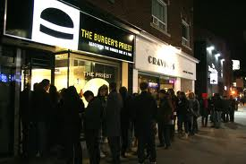
Baton Rouge (inside the Eaton’s Centre) - 216 Yonge Street
The Burger’s Priest - http://theburgerspriest.com/ - A pit stop ONLY for the HARD CORE burger fan; you’ll need to take a taxi to 1636 Queen Street East Toronto, ON M4L 1G3 - (647) 346-0617 (Prepare for a line up and to eat standing up. Except for two seats inside, there’s nowhere to sit. A truly “utopian” Toronto burger experience)

n) Dolce… Dolce… Dolce
http://dolcegelato.net/ – Best Gelato in Little Italy $
http://www.carolescheesecake.com/ – Gourmet Cheesecake in Yorkville $$
http://www.dessertlady.ca/ – Walk-in for locally created desserts - neat gifts for friends / family - Gourmet Cookies, Ice Cream, Cupcakes, truffles in Yorkville.
http://www.morocochocolat.com/ – Lovely Macrons, gourmet hot chocolate, fondue in Yorkville; $$
http://www.yelp.ca/biz/yoco-frozen-yogurt-toronto YOCO - Organic Frozen Yogurt + Toppings Bar in Yorkville with neat flavors (Lychee, Green Tea, etc.). Similar to Menchies in the Annex and Yogurty’s Froyo on the Danforth.
Future’s Bakery (the Annex)
Pusateri’s - http://pusateris.com/stores/yorkville/
DavidsTea – in the Annex http://www.davidstea.com

o) 24 Hour Grocery Stores: Rabba Fine Foods & Sobey’s
- Loblaws @ Carlton / Yonge (Maple Leaf Gardens)
- Whole Foods @ Hazelton Lanes (Yorkville)
PART (4) Entertainment in Toronto
Toronto has an almost endless variety of entertainment and hot-spots around the city. Here are some suggestions:
- Art Gallery of Ontario
- Royal Ontario Museum
- Verdi’s Il Travatore, at the Four Seasons Centre
- Toronto Football Club (v. DC United, Oct 6)
- Toronto Argonauts (v. Saskatchewan Roughriders, Oct 8)
- Steam Whistle Brewery tour, at the old Roundhouse
- Old Toronto Beer Lovers’ Tour http://www.beerloverstour.com/toronto.html
- War Horse, at the Princess of Wales Theatre
- Distillery District Tours http://www.thedistillerydistrict.com/tours.php
- Toronto Island & Ferry
- Harbourfront Centre
- Bata Shoe Museum
- Historic Casa Loma
- Soul Pepper: “Death of a Salesman” http://www.soulpepper.ca/performances/12_season/death_of_a_salesman.aspx#calendar
- The Second City, “We’ve Totally Probably Got This!”
- Shopping: Visit the Eaton’s Centre, Manulife Centre (Bay / Bloor), Yorkville
- TIFF LIGHTBOX - Watch a film @ the Toronto International Film Festival building (http://tiff.net/)
- Jazz @ The Rex Hotel - www.therex.ca (Live Jazz, 365 days-a-year)
- Check Toronto’s online guide: http://www.toronto.com/thingstodo/events
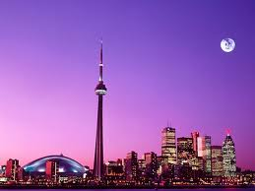

ENJOY YOUR STAY!
Brendon Langer & Christina Braid

